Marwadi University
Faculty of Computer Applications

BCA 4E Python Mid-1 Exam

Enrollment No. : 92400527009
Name : Luyanda Kunene
Class : BCA 4E
Date : 12/03/2025

Answer – 1

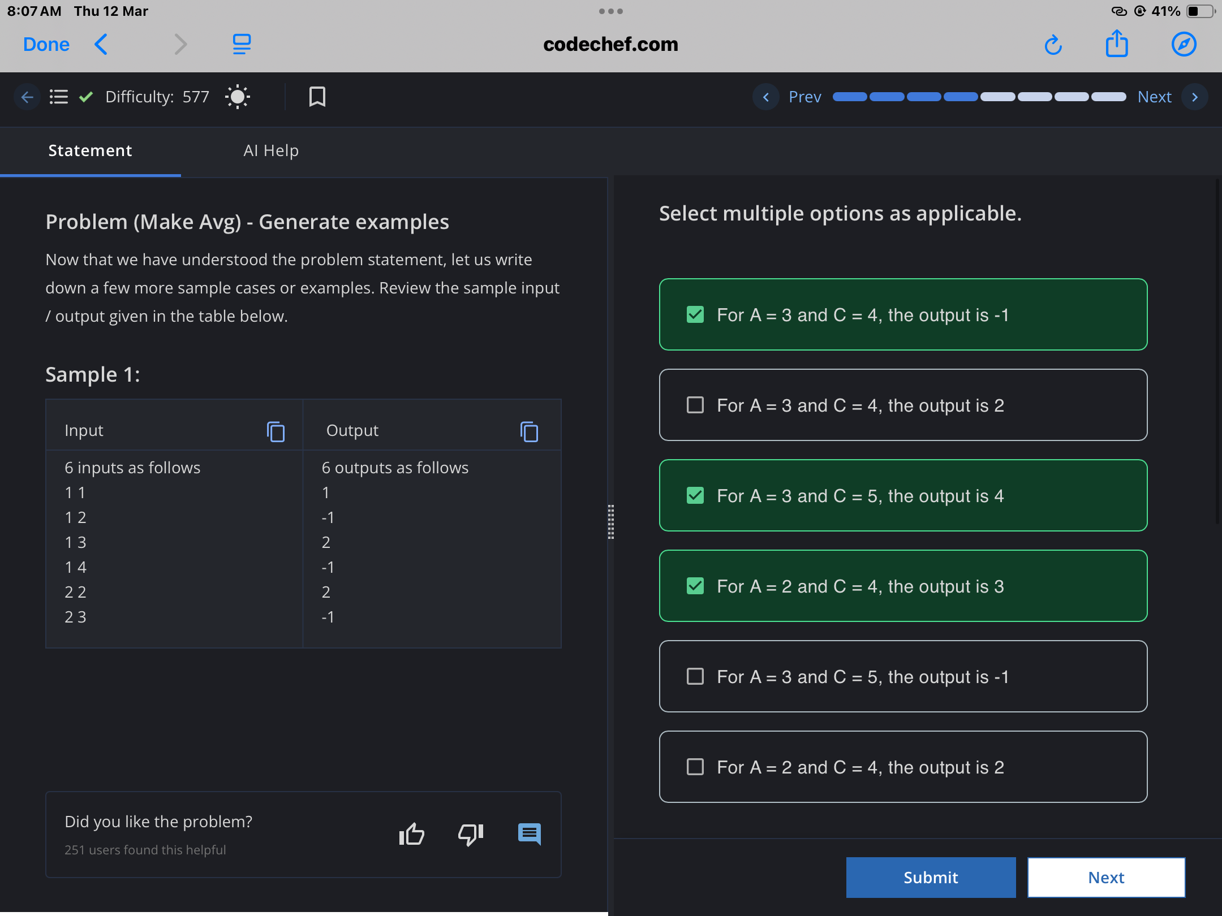

Answer – 2

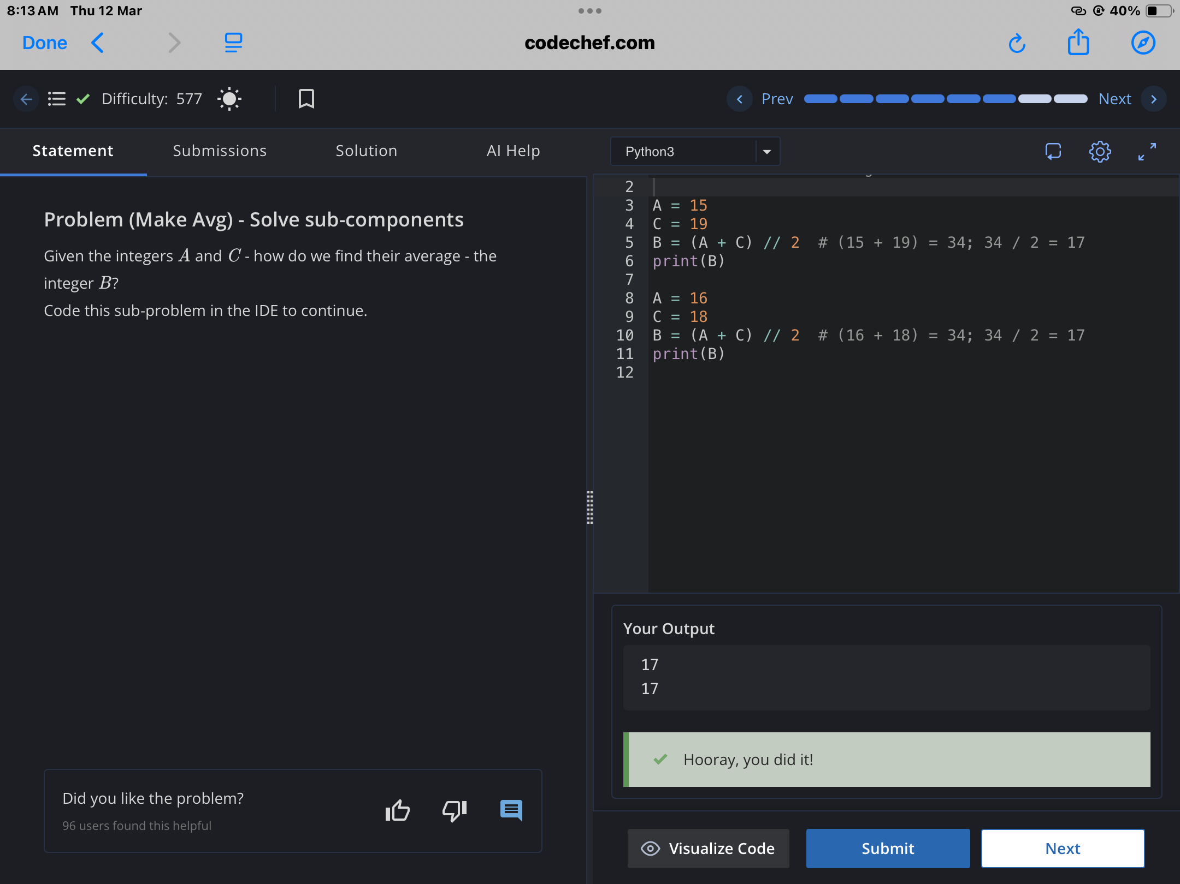

Answer – 3

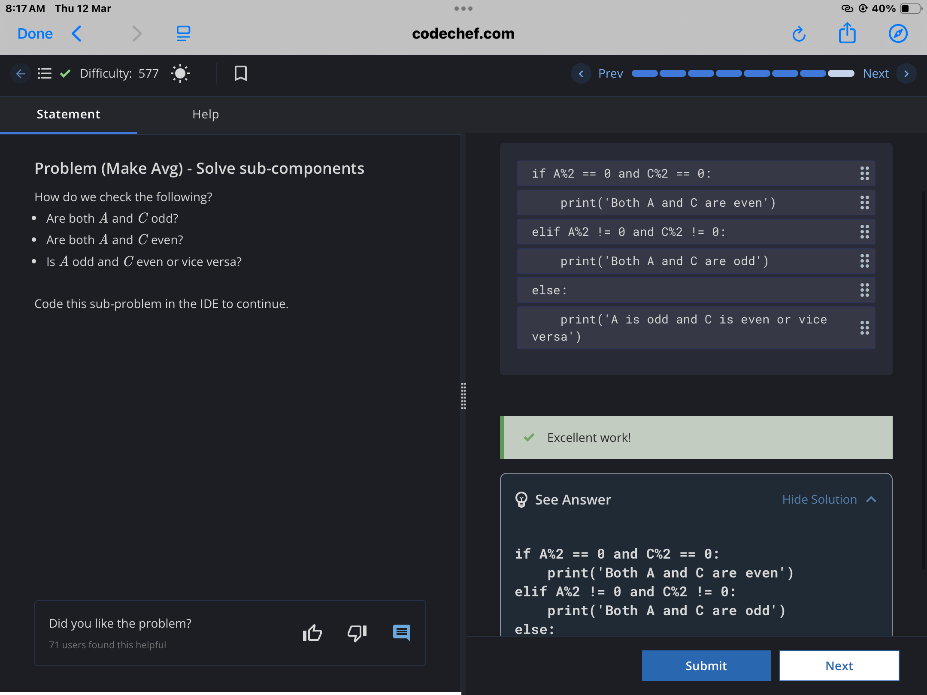

Answer – 4

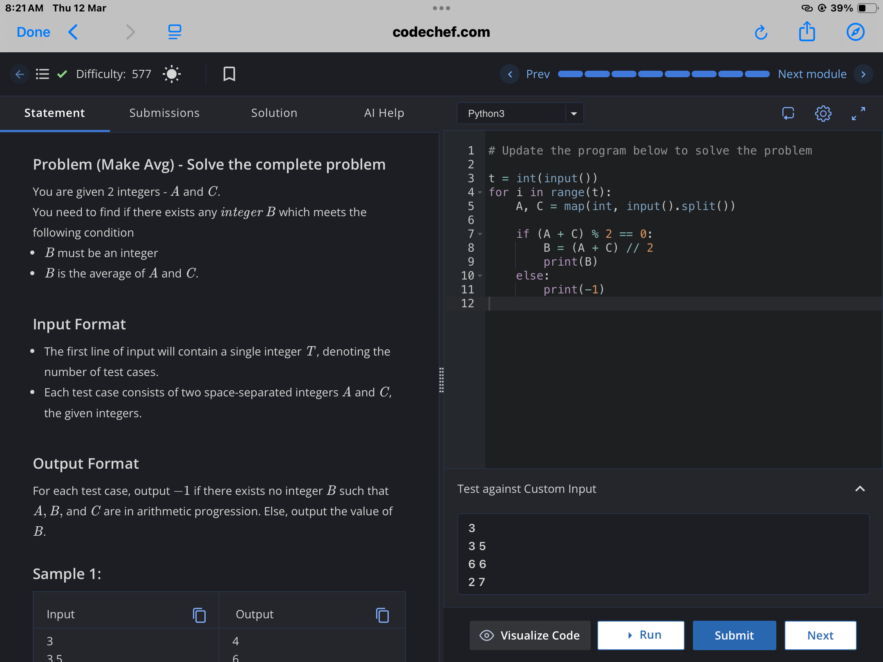

Answer - 5

